***AEC LAB REPORT – 2***

***DIODE CHARACTERIZATION AND APPLICATIONS***

***NAME:*** *Khyathi Sri Basireddy*

***ROLL NO****: 2023102065*

***TABLE NO****: 9*

***1.Diode Characteristics***

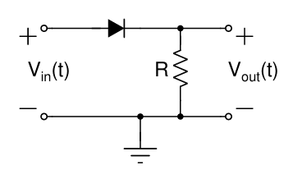

Given parameters:

R = 1k ohm

V = 1V

Freq = 200 Hz

**(a)Half wave rectifier**

1. Connect the diode in forward bias and give it a sinusoidal input and amplitude using the WaveGen with the parameters given above. The output is as follows.

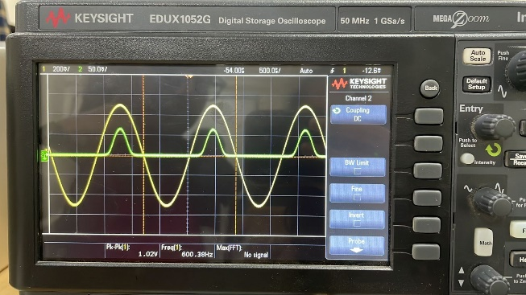

Until the Vin is equal to the V cutin voltage offered by the diode, the diode doesn’t allow current to flow through it and Vout is zero. After that we can see the Vout but the amplitude in positive cycles is a little lesser.

**(b) Transfer Characteristics**

Plotting voltage transfer characteristics on the oscilloscope using the X-Y mode by pressing the ‘Acquire’ button.

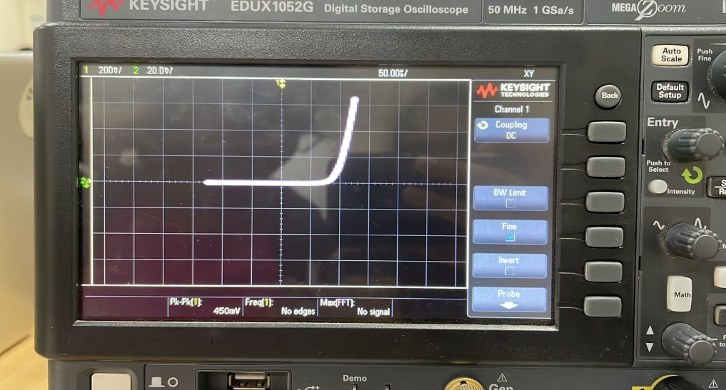

When Vin is greater than Vout, the graph would be a straight line with slope 1 and x-intercept as cut-in voltage. When Vin is less than Vout , the graph would be a straight line along x-axis.

**(c) Cut-in Voltage**

The observed cut-in voltage using cursor ranges from

* 295.35 mV to 396.0 mV
* 0.3V – 0.4V (approx)

**(d)Internal Resistance**

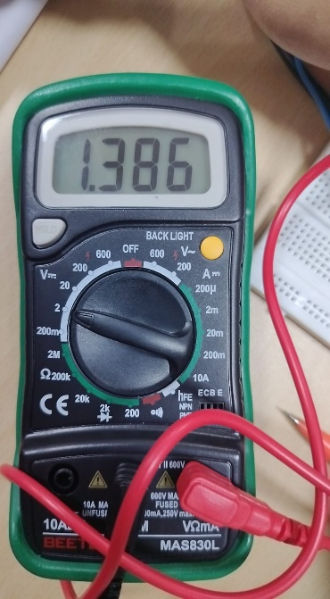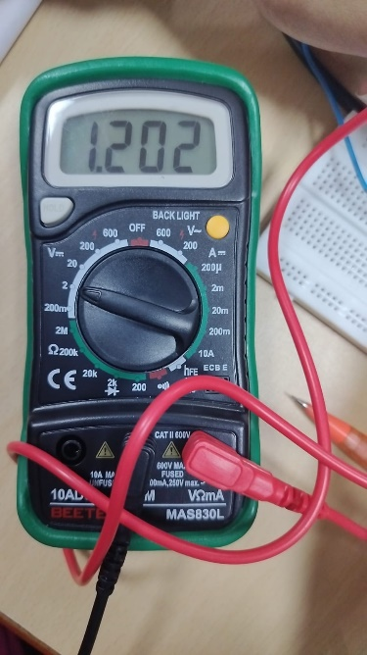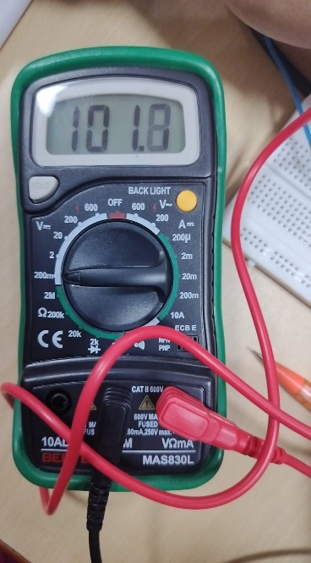

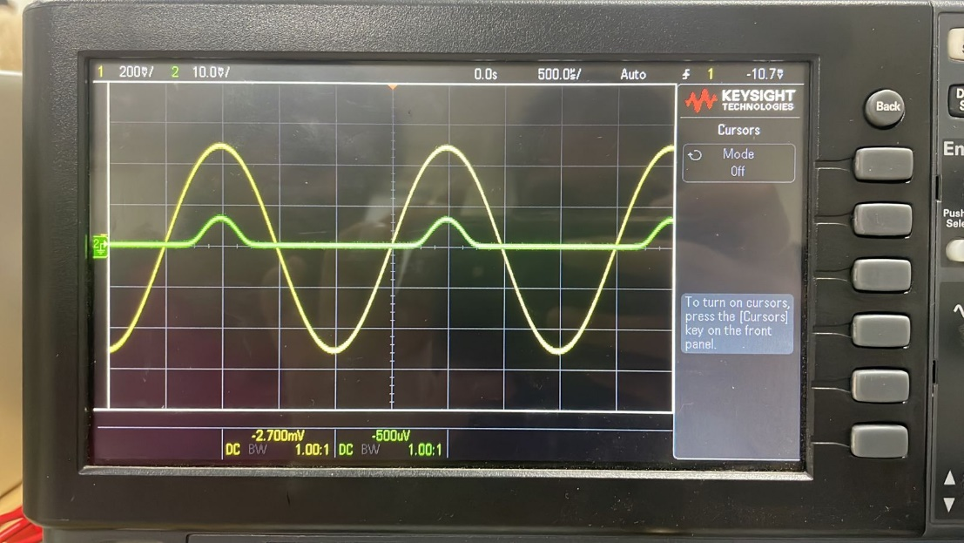

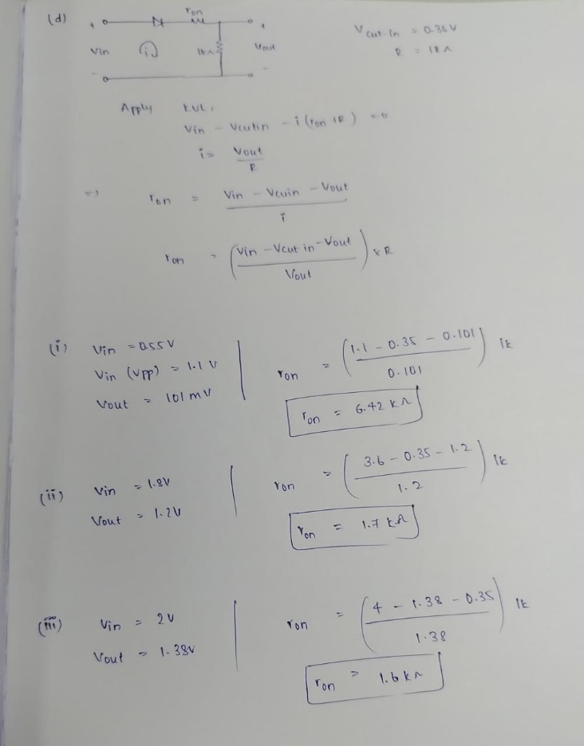

The result is as follows:

|  |  |  |
| --- | --- | --- |
| **V in** | **V out** | **Rd** |
| 0.55V | 101mV | 6.42k ohm |
| .8V | 1.2V | 1.7k ohm |
| 2V | 1.38V | 1.6k ohm |

**Observation:**

The internal resistance of the diode is inverse of the slope of the I-V characteristics of the diode.

As we see from the above results, as we increase V in then the Vout also increases proportionally. From the formula of ron derived above as Vin and Vout increases, the internal resistance decreases as the Vin increases.

**Formula:**

ron = ((Vin – Vcut-in -Vout)/Vout) *R

**(e) Transient Responses**

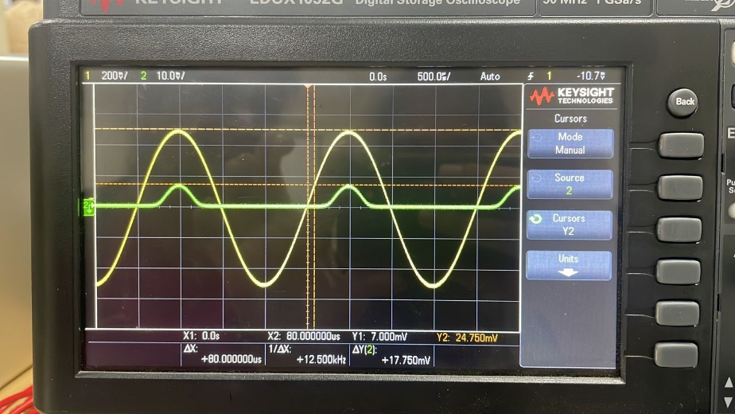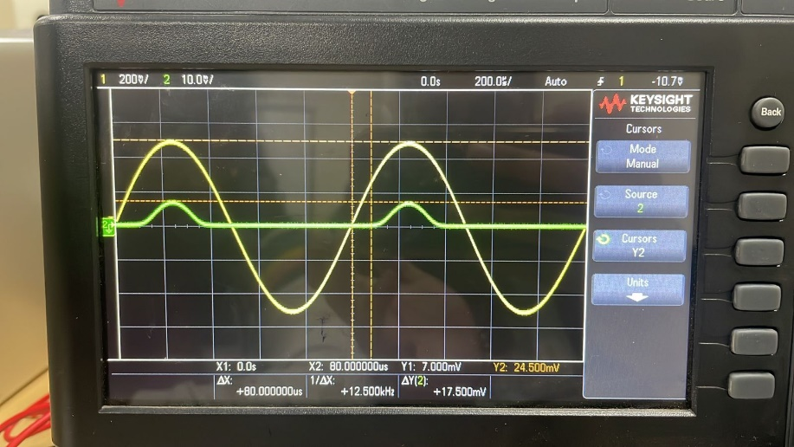

Frequency = 1kHz

Frequency = 500 Hz

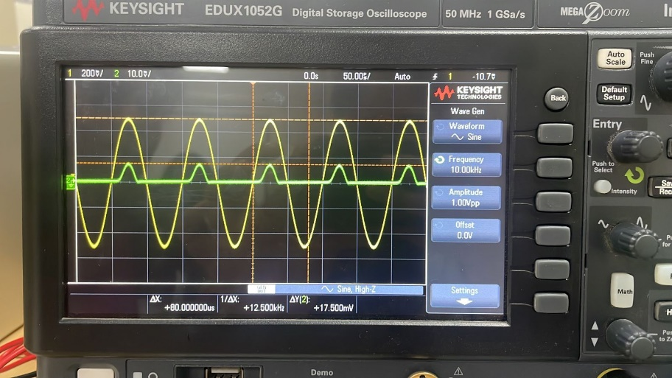

Frequency = 10kHz

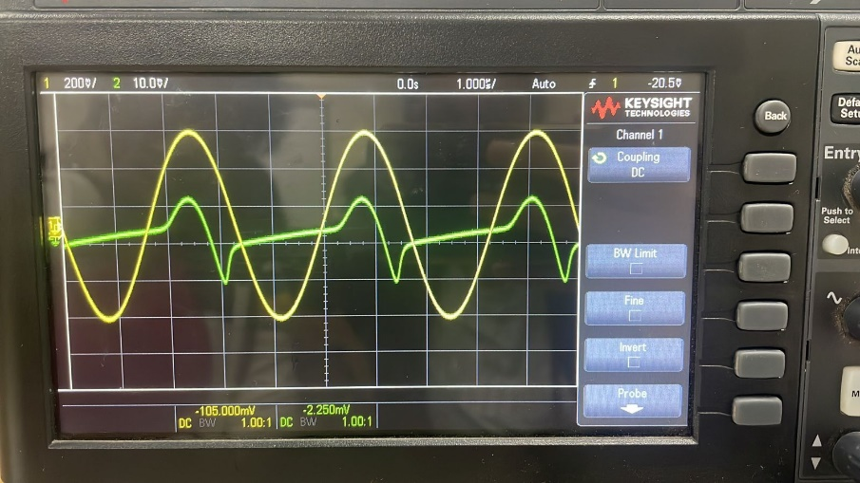

Frequency = 160kHz

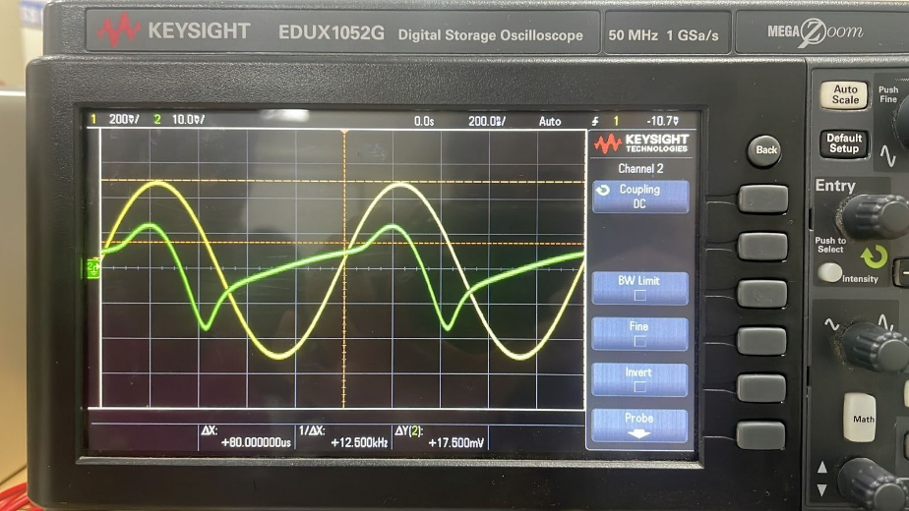

Frequency = 1Mhz

The output waveform may become distorted at higher frequencies because the diode may not be able to react to the changing input signal fast enough.

This is because the diode can only discharge and conduct current for a portion of the cycle due to its internal capacitance, which prevents the diode from turning on and off instantly. Consequently, the output waveform exhibits distortion and flattening of its peaks. However, with low frequency inputs, this is not an issue, and we obtain the desired output voltage.

**(f) With Capacitor**

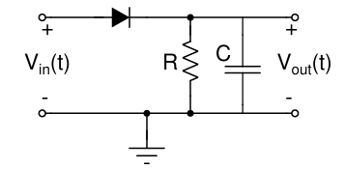

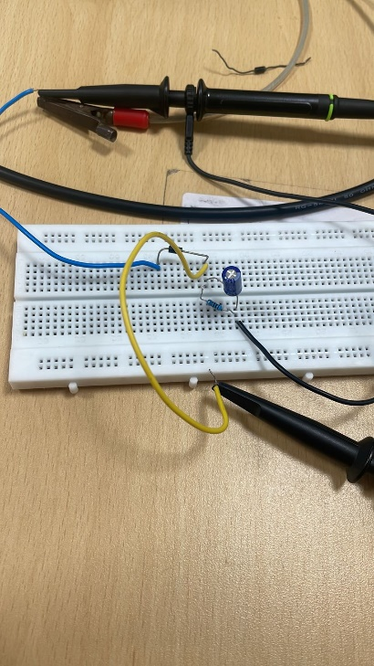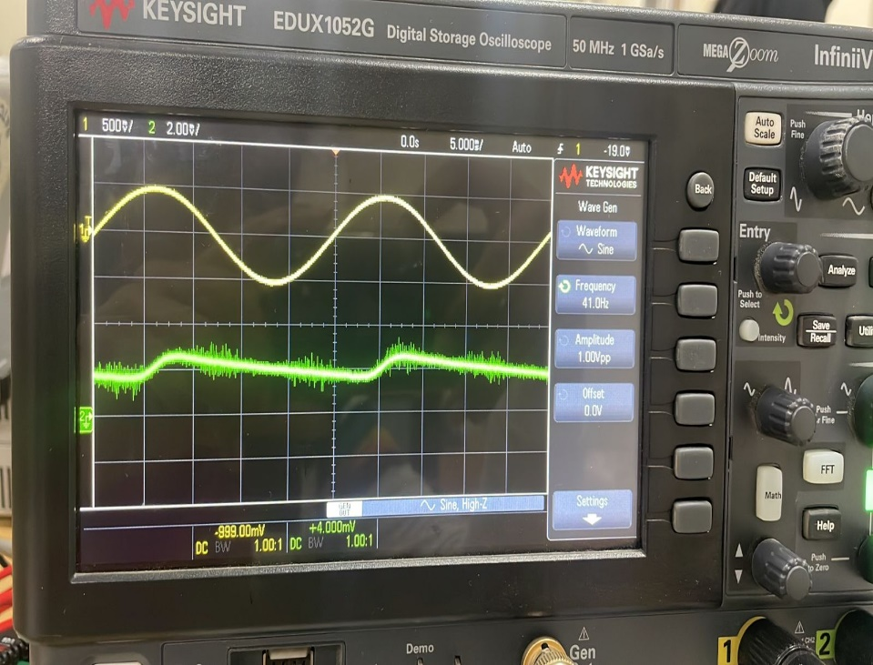

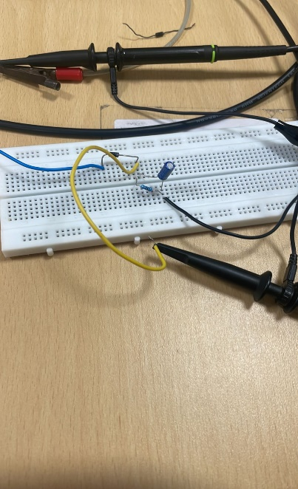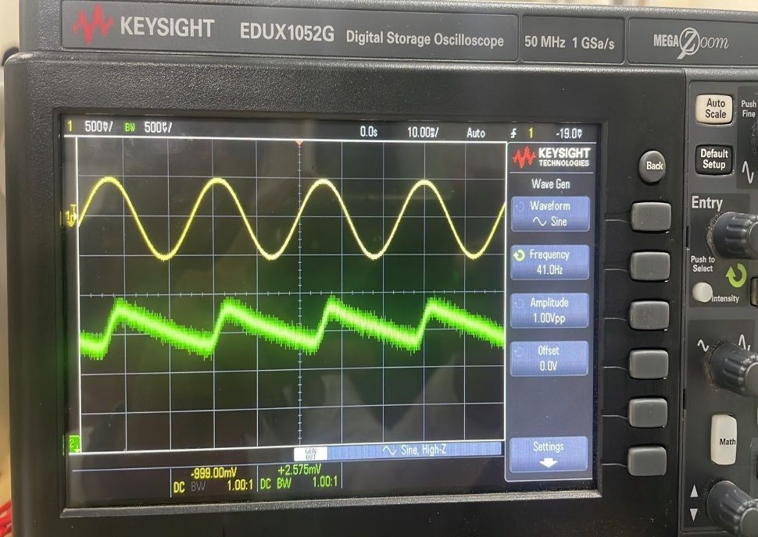

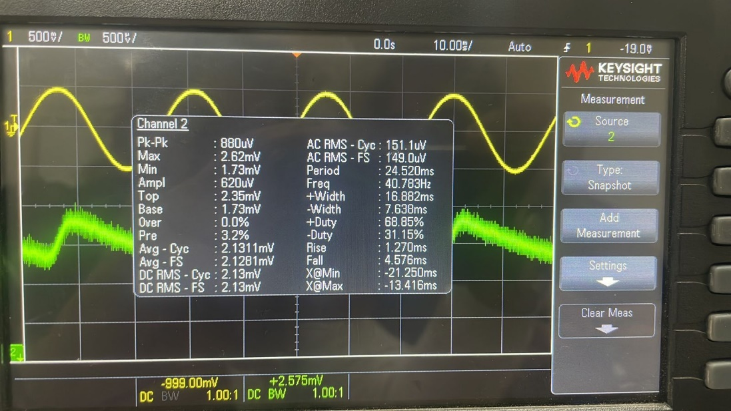

The capacitor charges when the diode is in forward bias. The Vout increases proportional to the Vin until it reaches the peak value. After that the diode changes into reverse bias and no current is present in the circuit. From here the capacitor starts to discharge as shown in the green colored graph.

And again when Vin starts increasing, until the peak is reached, the Vout increases and capacitor charges. Further it starts discharging as above.

***2. Clipper Circuits***

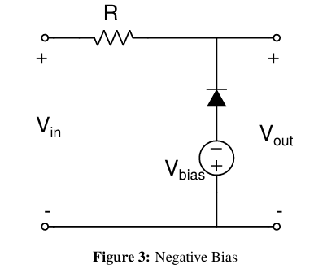

R = 1k ohm

Vin = 1V

**(a)**

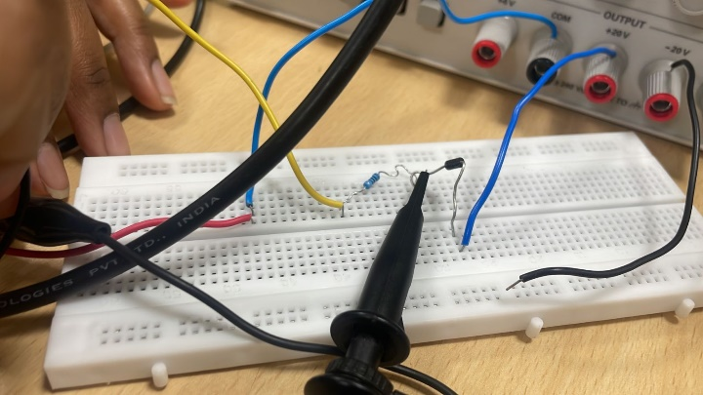

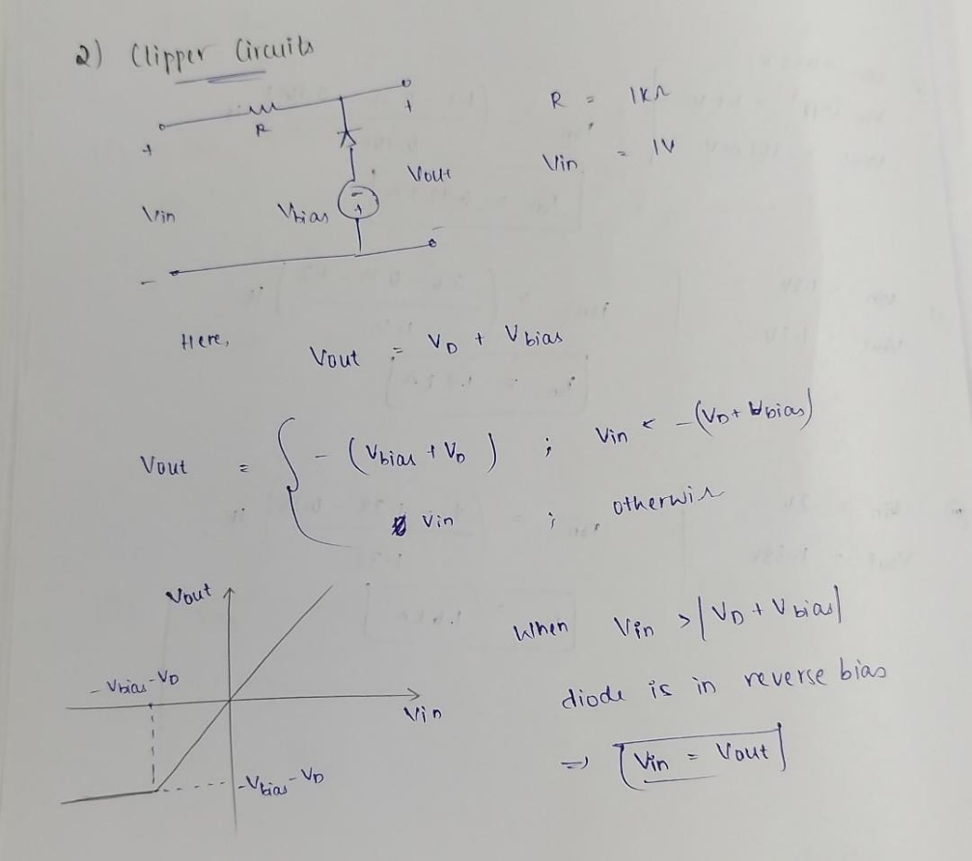

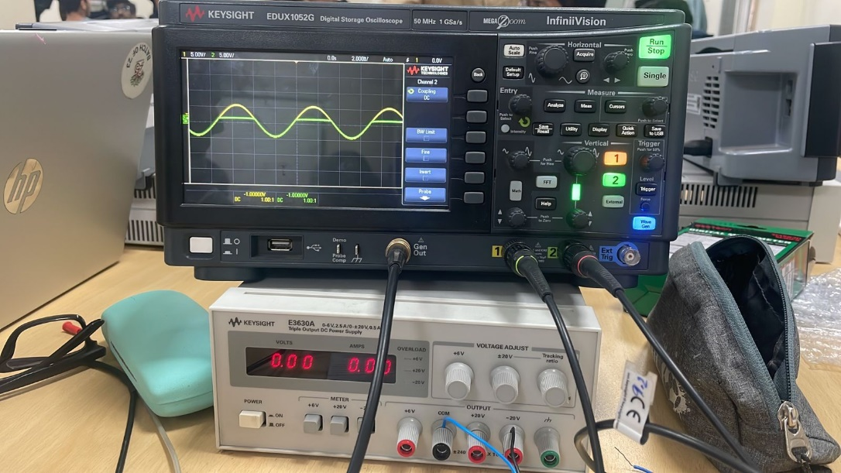 V bias = 0V

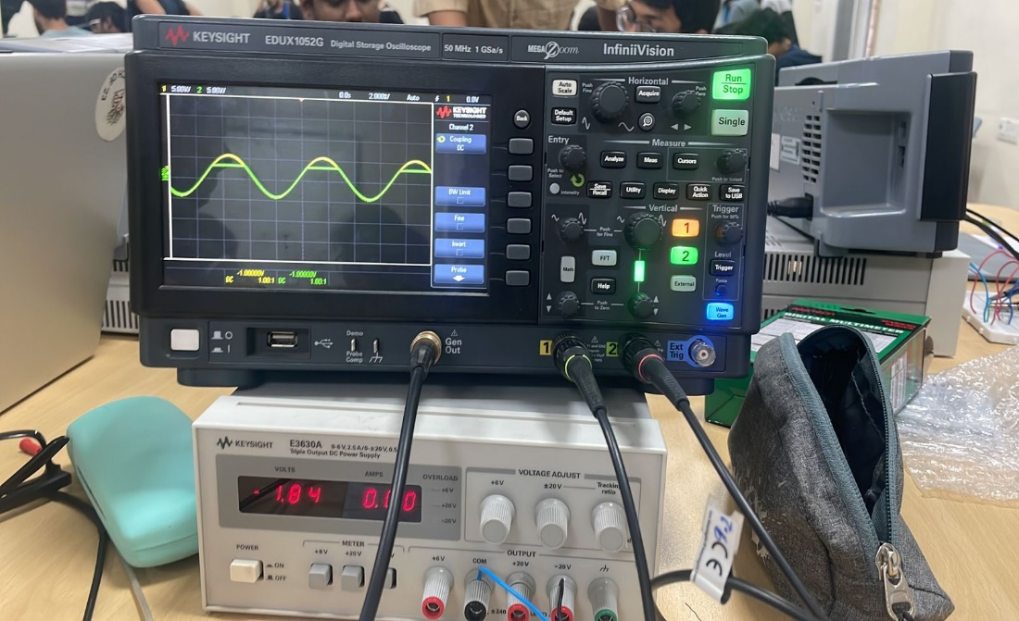 V bias = -1.84V

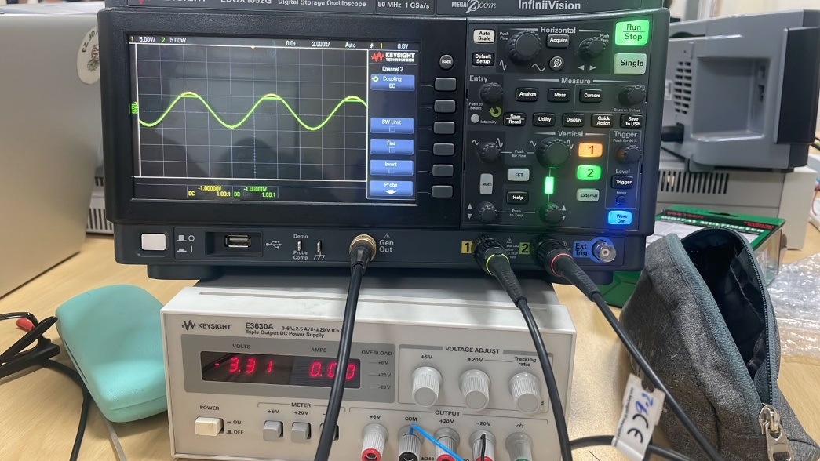 V bias = -3.31V

**(b) Transfer Characteristics**

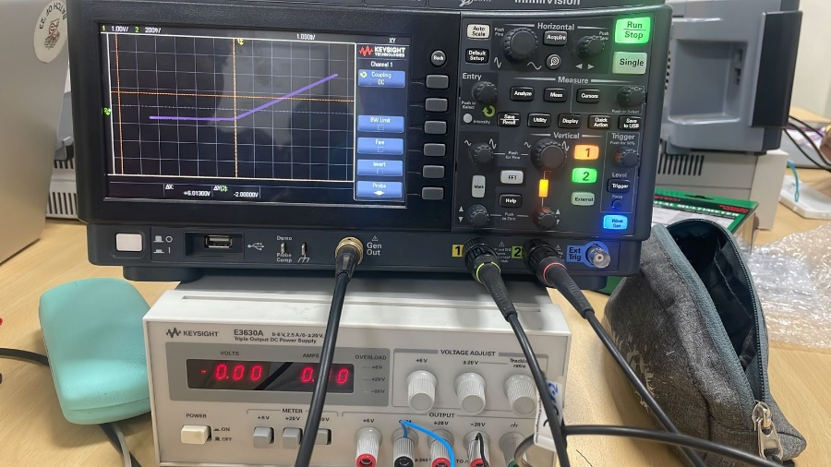V bias = 0V

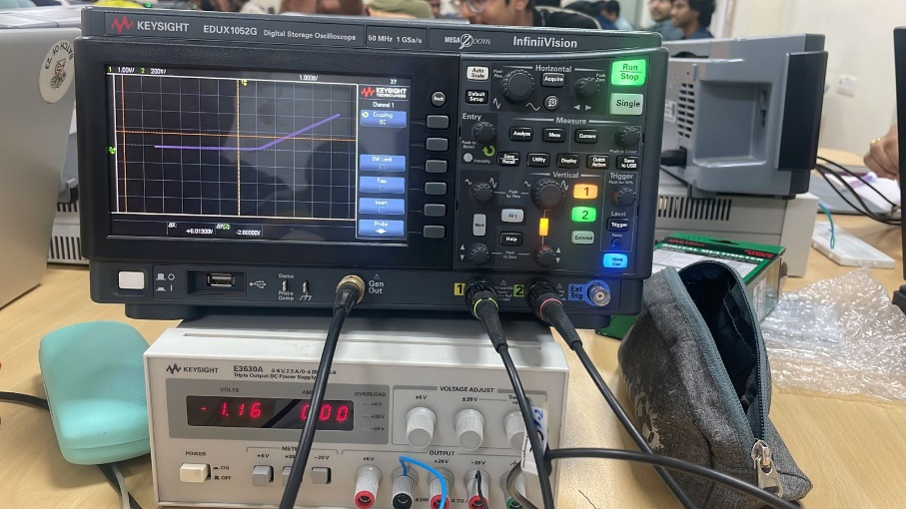 V bias = -1.16V

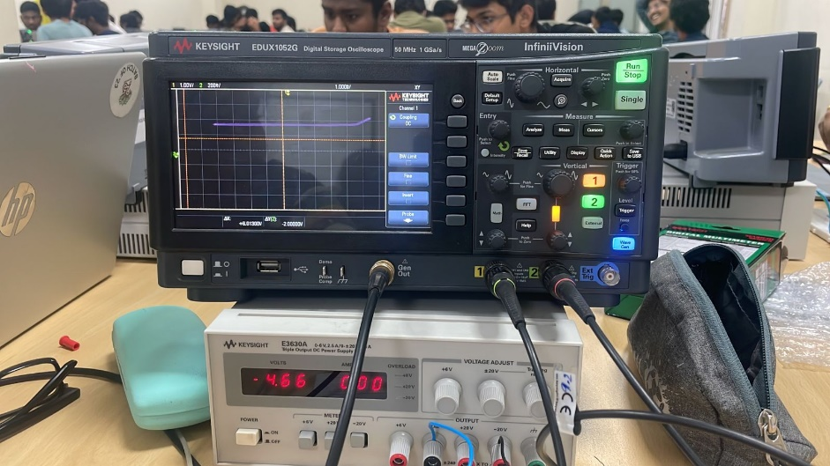 V bias = -4.66V

From the above understanding, the transfer characteristics would be

i. VOUT = -VBIAS-VCUT-IN for negative half cycle

ii. VOUT = -VBIAS-VCUT-IN when VIN > VBIAS + VCUT-IN

and VOUT = VIN when VIN < VBIAS + VCUT-IN

**(c) Clipping both the cycles**

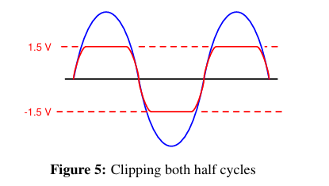

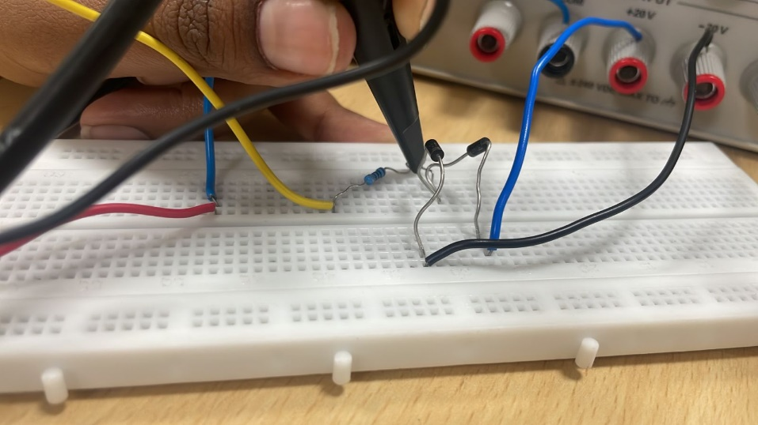

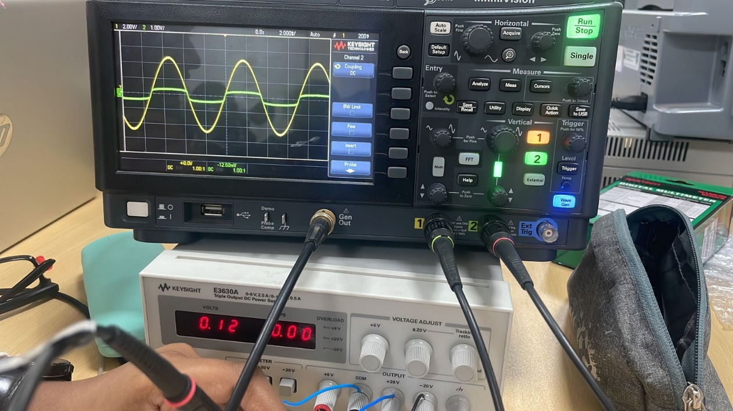

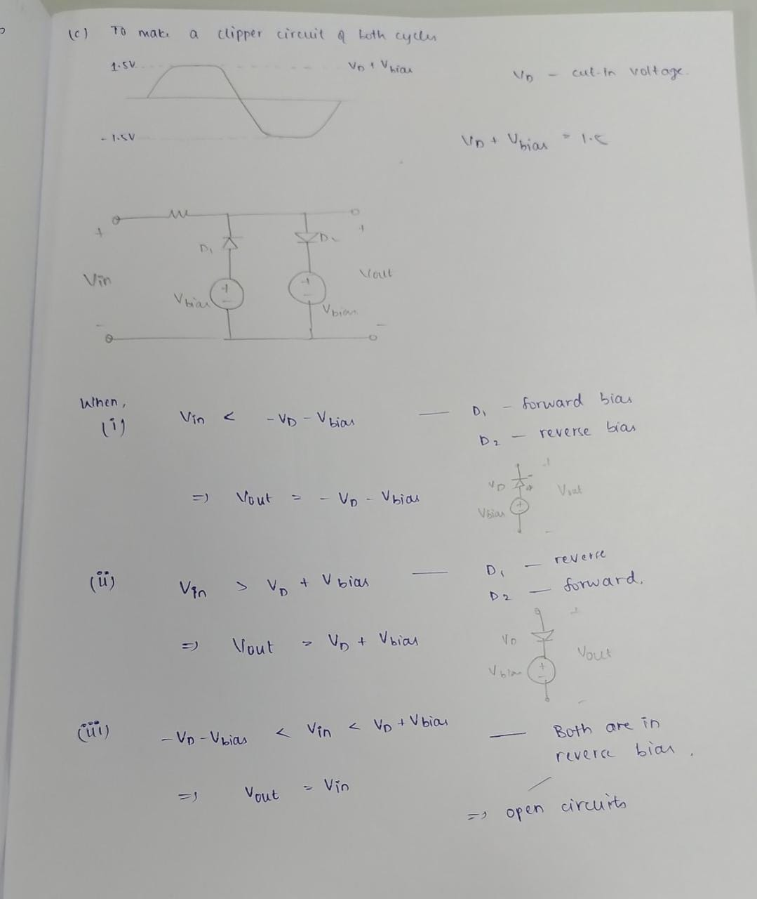

***3.Application of Diode in Energy Harvesting***

**(a) Meet the omnipresent- 50 Hz (noise) signal**

-> Connect the probe to oscilloscope channel and leave it in air, this acts as an antenna for the 50 Hz signal.

When the Probe is straight 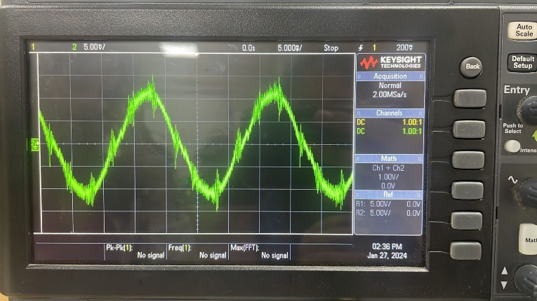

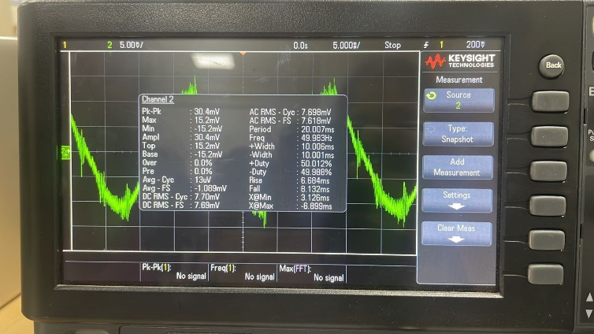

When the Probe is coiled and stretched

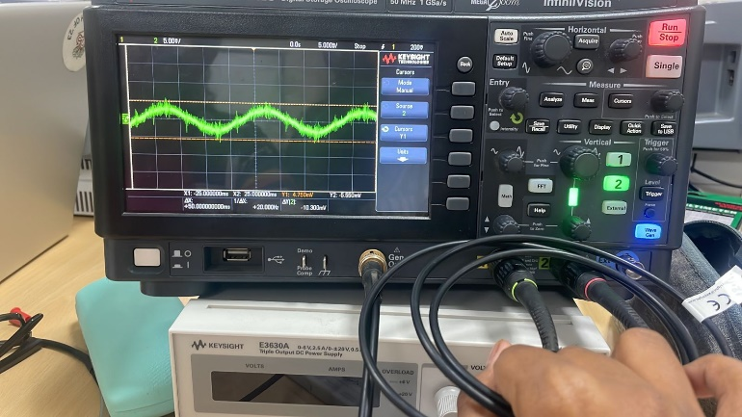

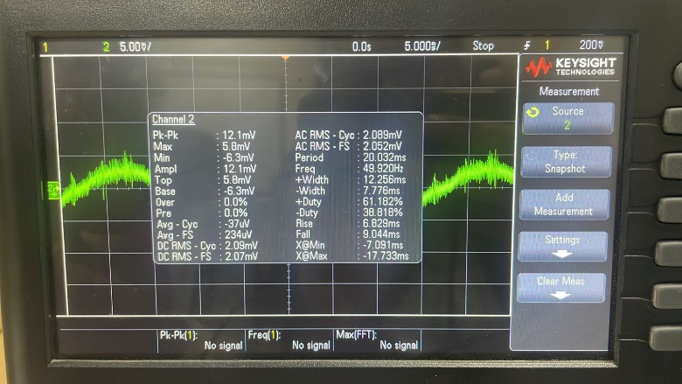

From the snapshots taken above, we can see that, when coil is straight the amplitude is 30.4mV and when it is coiled the amplitude is 12.1mV.

The difference is almost 18.3mV.

**b) A simple energy harvester**

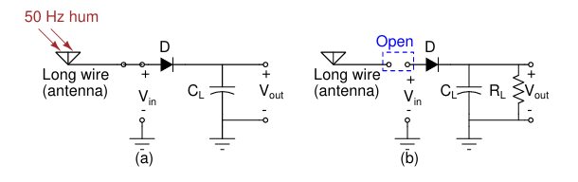

1.Connect the diode and capacitors as shown above. CL = 100 uF

2.Short the terminals to ground and discharge Cl initially.

3. Connect oscillator probe at the output and measure voltage (you should see 0 V)

4. Connect a big wire (You can use the BNC cable from the function generator.) and measure amplitude of 50 Hz signal using other channel of oscilloscope.

5. Now start charging the capacitor slowly until it reaches 300mV. We can see that the capacitance gradually increases and this results in storage of energy.

6. After it reaches 300mV , connect a resistor of 1k ohm as shown in circuit (b).

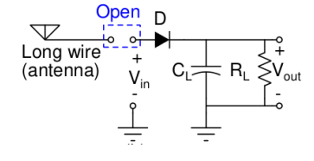

Now, we can notice that the capacitor slowly starts to discharge while current flows through the resistor.

7. In this way we have successfully stored energy harvested from the surroundings.

